Physics and Introduction to Science Topic Test 1

Name: _____________________________________ Mark: /50

**SECTION A: MULTIPLE CHOICE (15 marks)**

**Please answer on the separate multiple choice answer grid sheet provided.**

**1.** A stretched spring stores energy as:

(a) Elastic kinetic energy.

(b) Elastic potential energy.

(c) Impact kinetic energy.

(d) Impact potential energy.

**2.** Choose the correct definition for ‘potential energy’.

(a) Energy found in moving light energy.

(b) Energy found in moving sound waves

(c) Energy that is stored.

(d) Any energy of movement.

**3.** Choose the correct definition for ‘kinetic energy’.

(a) Energy that is stored in chemicals.

(b) Energy that is stored in a stretched object.

(c) The energy of a moving object.

(d) The energy stored in a litre of fuel.

**4**. Two common units of measure for speed are:

(a) Km/h and ml.

(b) m/s and grams.

(c) m/s and Joules.

(d) m/s and Km/h.

**5.** In a kilojoule, there are:

(a) 10 joules.

(b) 100 joules.

(c) 10,000 joules.

(d) 1000 joules.

**6.** The equation for gravitational potential energy is

GPE=m x g x h

(Remember gravity is always 9.8).

Kate has a mass of 40kg and sits on the edge of a 3m high wall. Which of the following would be her gravitational potential energy?

(a) 1,176g.

(b) 1,176 J.

(c) 546J.

(d) 546g.

**7.** Choose the correct definition for ‘gravitational potential energy’.

(a) Energy stored in an object when it is above the ground.

(b) Energy stored in a stretched or squashed object.

(c) The force per unit area.

(d) The rate that a task is accomplished.

8. Biology is:

(a) the study of living things.

(b) the study of energy.

(c) the study of matter.

(d) the study of Mass.

9. Choose the correct statement below.

(a) mass is measured in litres.

(b) temperature measured in Joules.

(c) Temperature measured in grams.

(d) energy measured in joules.

10. Anything that takes up space and has mass is called:

(a) Matter

(b) Temperature.

(c) Chemistry

(d) Gravity

11. Gravity is the Force that:

(a) pulls objects to the surface of the Earth.

(b) is found in all fast moving objects.

(c) is found in all slow moving objects

(d) only exists on the planet Earth

12. Science is:

(a) Anything has mass and takes up space.

(b) The study on only living things.

(c) Matter energy and how both of them interact.

(d) The study of everything in the universe in attempt to find information, [explanations](http://en.wikipedia.org/wiki/Scientific_theory) and [predictions](http://en.wikipedia.org/wiki/Predictability) about the [universe](http://en.wikipedia.org/wiki/Universe).

13. Unburned firewood is shown in the picture below.

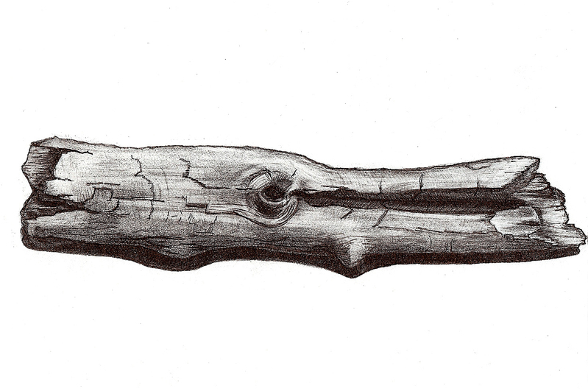

It contains:

(a) Chemical kinetic energy.

(b) Chemical potential energy.

(c) Elastic potential energy.

(d) Elastic kinetic energy.

14. Speed is:

(a) chemical kinetic energy.

(b) a measure of temperature.

(c) a measure of how fast an object is moving.

(d) a measure of volume/capacity.

15. When we burned Burger rings in class we converted the chemical energy in the food into:

(a) food.

(b) heat.

(c) wind energy.

(d) potential energy.

**SECTION B: SHORT ANSWER (35 marks)**

1. Write the meaning of the words into the table.

|  |  |
| --- | --- |
| WORD | MEANING |
| PHYSICS |  |
| ENERGY |  |

(2 marks)

1. Connect the correct unit of measure with correct quantity.

|  |  |  |
| --- | --- | --- |
| Quantity | USE AN ARROW TO JOIN THE CORRECT unit of measure TO THE CORRECT quantity | Unit of measure |
| Mass |  | Liters(L) |
| Temperature |  | Joules(j) |
| Energy |  | Grams (g) |
| Volume |  | Degrees centigrade (oC) |

(4 marks)

1. Write the name of the types of kinetic energy shown in each of the pictures below.

|  |  |
| --- | --- |
| Type of energy | Picture |
|  | [http://t1.gstatic.com/images?q=tbn:WYR5vf-gLX3z5M:http://openclipart.org/people/webmichl/webmichl_light_bulb.png](http://images.google.com.au/imgres?imgurl=http://openclipart.org/people/webmichl/webmichl_light_bulb.png&imgrefurl=http://openclipart.org/media/files/webmichl/4351&usg=__yW7Z6rWHy4n5is-lkBFcss7_dBs=&h=598&w=351&sz=57&hl=en&start=56&tbnid=WYR5vf-gLX3z5M:&tbnh=135&tbnw=79&prev=/images?q=light+bulb&gbv=2&ndsp=21&hl=en&sa=N&start=42) |
|  | [http://t2.gstatic.com/images?q=tbn:50mSA_we1h9eSM:http://kids.niehs.nih.gov/sharon/images/2boomlast.gif](http://images.google.com.au/imgres?imgurl=http://kids.niehs.nih.gov/sharon/images/2boomlast.gif&imgrefurl=http://kids.niehs.nih.gov/sharon/sharon2.htm&usg=__mNgD17aWNsFd17Dw0YbndmjK8l8=&h=235&w=241&sz=5&hl=en&start=17&tbnid=50mSA_we1h9eSM:&tbnh=107&tbnw=110&prev=/images?q=loud+noise&gbv=2&hl=en&sa=X) |
|  | [http://t3.gstatic.com/images?q=tbn:mnPv30TCZxpXdM:http://www.upminsterwindmill.co.uk/Copy_of_WINDMILL-1.jpg](http://images.google.com.au/imgres?imgurl=http://www.upminsterwindmill.co.uk/Copy_of_WINDMILL-1.jpg&imgrefurl=http://www.upminsterwindmill.co.uk/&usg=__vqombJx1qh74V91YKYrEAY7Eq0s=&h=535&w=500&sz=18&hl=en&start=19&tbnid=mnPv30TCZxpXdM:&tbnh=132&tbnw=123&prev=/images?q=windmill&gbv=2&hl=en&sa=G) |
|  | http://www.clubofthewaves.com/arttutorials/types01.jpg |

(5 marks)

1. A coconut in the tree below has a mass of 2kg. It is 3m off of the ground. Calculate the gravitational potential energy of the coconut. Show all working. (2 marks)

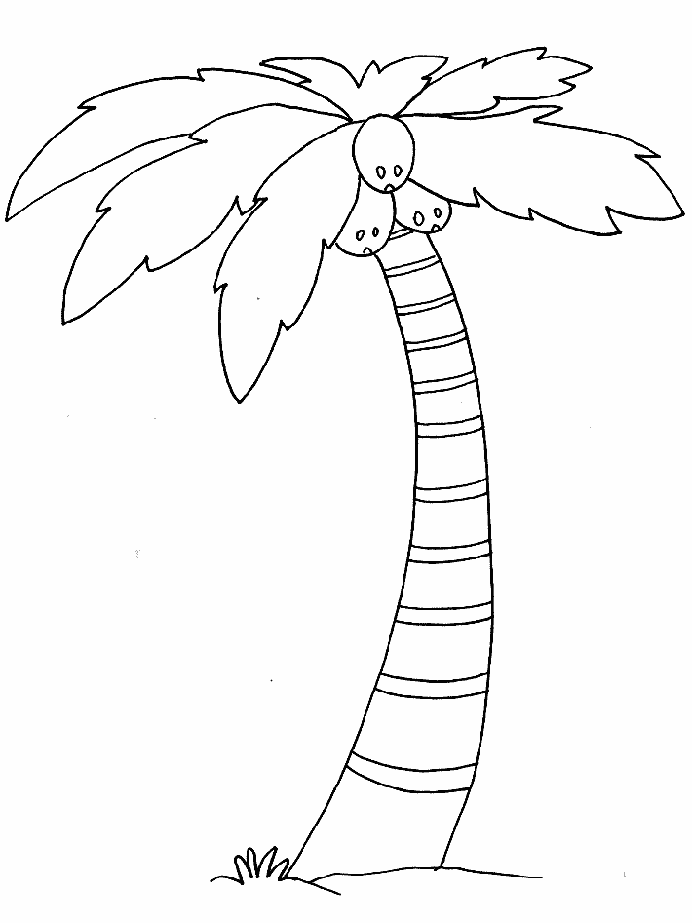

GPE= mass x gravitational constant x height

1. Classify the following as potential or kinetic energy.

|  |  |
| --- | --- |
| Situation | Kinetic or potential |
| [http://t2.gstatic.com/images?q=tbn:J39yIJKe7yop-M:http://cache4.asset-cache.net/xc/sb10065508i-001.jpg%3Fv%3D1%26c%3DNewsMaker%26k%3D2%26d%3DD30A939CD3593F448EC1FAB670BD34096C13D7D6104E221FE30A760B0D811297](http://images.google.com.au/imgres?imgurl=http://cache4.asset-cache.net/xc/sb10065508i-001.jpg?v=1&c=NewsMaker&k=2&d=D30A939CD3593F448EC1FAB670BD34096C13D7D6104E221FE30A760B0D811297&imgrefurl=http://www.gettyimages.com/detail/sb10065508i-001/Stone&usg=__C-V9sBeKEiLWomX-cG9L3S7L8So=&h=512&w=334&sz=13&hl=en&start=1&tbnid=J39yIJKe7yop-M:&tbnh=131&tbnw=85&prev=/images?q=standing+on+diving+board&gbv=2&ndsp=21&hl=en&sa=N)  A diver before they jump. |  |
| [http://t3.gstatic.com/images?q=tbn:fXEL9fMbo_4nYM:http://z.about.com/d/esl/1/0/P/2/diving.gif](http://images.google.com.au/imgres?imgurl=http://z.about.com/d/esl/1/0/P/2/diving.gif&imgrefurl=http://esl.about.com/od/engilshvocabulary/ig/Visual-Dictionary---Sports/Diving.htm&usg=__RfuX5CZkaIz9XIFdmAcpArag918=&h=326&w=490&sz=6&hl=en&start=2&tbnid=fXEL9fMbo_4nYM:&tbnh=86&tbnw=130&prev=/images?q=diving&gbv=2&ndsp=21&hl=en&sa=N)  A diver jumping and **moving** downwards to the pool. |  |
| [http://t0.gstatic.com/images?q=tbn:PYvAcCZ6JJ7-HM:http://classroomclipart.com/images/gallery/Clipart/Food/Breakfast_Clipart/food_clipart_075.jpg](http://images.google.com.au/imgres?imgurl=http://classroomclipart.com/images/gallery/Clipart/Food/Breakfast_Clipart/food_clipart_075.jpg&imgrefurl=http://classroomclipart.com/cgi-bin/kids/imageFolio.cgi?action=view&link=Clipart/Food/Breakfast_Clipart&image=food_clipart_075.jpg&img=&tt=&usg=__3KvZntF8DtJkQVk3lhXPzSZRPmY=&h=437&w=600&sz=48&hl=en&start=12&tbnid=PYvAcCZ6JJ7-HM:&tbnh=98&tbnw=135&prev=/images?q=food+clipart&gbv=2&hl=en&sa=G)  Energy in the chemicals that makes up the food. |  |
| [http://t0.gstatic.com/images?q=tbn:mL1gVi7Sx4QQvM:http://www.freewebs.com/whittysportscamp/spring_clipart_rain-726645.gif](http://images.google.com.au/imgres?imgurl=http://www.freewebs.com/whittysportscamp/spring_clipart_rain-726645.gif&imgrefurl=http://www.freewebs.com/whittysportscamp/campcancellationpolicy.htm&usg=__yDJErXpWIEvmHUh2YOby668Aows=&h=200&w=170&sz=5&hl=en&start=4&tbnid=mL1gVi7Sx4QQvM:&tbnh=104&tbnw=88&prev=/images?q=rain+clipart&gbv=2&hl=en&sa=G)**falling** rain |  |
| [http://t2.gstatic.com/images?q=tbn:ZfvaV9mYnor5vM:http://comps.fotosearch.com/comp/UNC/UNC340/action-bicycle-bicyclist_~u14397786.jpg](http://images.google.com.au/imgres?imgurl=http://comps.fotosearch.com/comp/UNC/UNC340/action-bicycle-bicyclist_~u14397786.jpg&imgrefurl=http://www.fotosearch.com/UNC340/u14397786/&usg=__EKb1wbgjVdk7TuVUeMybvwKdF_k=&h=320&w=300&sz=30&hl=en&start=30&tbnid=ZfvaV9mYnor5vM:&tbnh=118&tbnw=111&prev=/images?q=bike+clipart&gbv=2&ndsp=21&hl=en&sa=N&start=21)**moving** bike |  |
| [http://t3.gstatic.com/images?q=tbn:W7uPQBbiDd_OxM:http://coolshade.tamu.edu/images/sunb.gif](http://images.google.com.au/imgres?imgurl=http://coolshade.tamu.edu/images/sunb.gif&imgrefurl=http://coolshade.tamu.edu/htech04/vpsa_cancerman/cancerman.htm&usg=__1Uf8Zs0pqfecrezDxzXWLV79x7M=&h=232&w=238&sz=5&hl=en&start=14&tbnid=W7uPQBbiDd_OxM:&tbnh=106&tbnw=109&prev=/images?q=sun+drawing&gbv=2&hl=en&sa=G) The light energy is **moving** from the sun to you |  |

(6 marks)

1. Connect the correct quantity with the correct piece of equipment used to measure it.

|  |  |  |
| --- | --- | --- |
| Quantity | USE AN ARROW TO JOIN THE CORRECT unit of measure TO THE CORRECT quantity | Equipment |
| Volume |  | Scales and balances |
| Temperature |  | Thermometer |
| Mass |  | Measuring cylinder |

(3 marks)

1. (a) A man rides his bike for 2 hours and travels 40km. What was his average speed? Show all of your working.

(2 marks)

**Speed= distance**

**time**

(b) An aeroplane moves 500km in 2 hours. What was its average speed?

(2 marks)

1. You can calculate the kinetic energy a moving object has if you know its mass and speed. The formula below shows how this can be done.

Kinetic energy= 1/2 of the objects Mass X the objects speed squared

[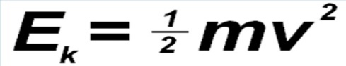](http://www.google.com.au/url?sa=i&rct=j&q=kinetic+energy+equation&source=images&cd=&cad=rja&docid=See6Fh-OKCTFWM&tbnid=Bc85jkUPcsgKhM:&ved=0CAUQjRw&url=http://www.formula1journal.com/2010/08/kinetic-energy-recovery-systems-by-sportsman.html&ei=_uUbUrrvGZDbkgWn84G4Dg&psig=AFQjCNGLnE1JnJzjXHzogdd9awRSOFrRjg&ust=1377646428409459)

1. A car has a mass of 1000kg and is rolling at a speed of 5 m/s. How much kinetic energy does it have? Show all working.

(3 marks)

1. A falling rock has a mass of 5kg falls at a speed of 10m/s. How much kinetic energy does it have? Show all working.

(3marks)

1. Complete the table below.

|  |  |
| --- | --- |
| Mass | |
| Grams (g) | Kilograms(Kg) |
| 3,000 |  |
| 500 |  |
|  | 7.5 |
| 2750 |  |
|  | 0.7 |
|  | 1.2 |

(3 marks)

**Multiple Choice Answer Sheet**

**Name_____________________________________________**

1. A B C D

2. A B C D

3. A B C D

4. A B C D

5. A B C D

6. A B C D

7. A B C D

8. A B C D

9. A B C D

10. A B C D

11. A B C D

12. A B C D

13. A B C D

14. A B C D

15. A B C D